**CHAPTER 1**

**ABOUT THE COMPANY**

**1.1 Brief history of the Organization**

With the active participation of its multi-disciplinary Assignment Execution Team, Pralotech Solutions has emerged as a leader in the ITES in India and has established itself in the field of software development, data processing, data conversion, digital printing, Digitization, System integration, smart card personalization, IT facility management and other IT enabled services. Pralotech Solutions LLP, incorporated in end of 2018, is a professionally managed, rapidly growing, multifaceted Information technology company. The company is actively involved in developing automation and e-Governance solutions for Transport, Social Security, Citizen Identity, Education, Public Distribution System, Retail Management and a host of other application areas.

Pralotech Solutions is a leading System integrator in India providing complete turnkey solutions on BOO & BOOT basis including facility management services, Smart Cards applications, Document Management System (DMS), Work Flow Management and Manpower Deployment.

Pralotech Solutions has successfully completed many e-governance projects for the various departments of Govt of Karnataka and has won accolades for its superior service delivery, timely execution of projects and the quality of the deliverables. PRALOTECH SOLUTIONS is being trusted by many clients who are looking for reliable and quality services for their business. PRALOTECH SOLUTIONS is currently operating and managing in Bangalore and giving services to e-commerce business services.

Pralotech Solutions adopted project team and dedicated organization structure. In project based organization, the project managers directors have a high level of power to oversee and control the project assets. The project manager in this structure has downright power over the project and can secure assets expected to fulfill project targets from inside then again outside the parent organization, subject just to the extension, quality, furthermore, budget constraints are identified in the project.

In the project based structure, staff is particularly relegated to the project and report specifically to the project manager. The project manager is in charge of the execution evaluation and vocation movement of all undertaking colleagues while on the project. This prompts expanded project faithfulness. Complete line power over undertaking endeavors bears the project manager solid undertaking controls and brought together lines of correspondence. This prompts quick response time and enhanced responsiveness. In addition, project work forces are held on a restrictive instead of shared or low maintenance premise. Project teams create an in number feeling of task recognizable proof and possession, with profound faithfulness efforts to the project and a decent comprehension of the way of project's exercises, mission, or objectives.

* 1. **Overall Organization Structure**

Pralotech Solutions is completely dedicated to the success of our customers and does not permit external forces to diminish our focus and commitment.  To achieve the highest level of customer satisfaction, we follow basic principles to deliver solutions with impact.

**1.2.1 Vision:**

Vision Statement: “To be the pioneer in e-commerce solutions by building and implementing robust and future proof systems which are efficient, transparent and accountable.”

**1.2.2 Our Values:**

The core values which lay the foundation for Pralotech Solutions are:

* Honesty & Integrity: Pralotech Solutions individual and business relationships are governed by the highest standards of honesty and integrity. People at all levels adhere to the code of conduct and the highest standards of business ethics, as they believe in conducting their business with uncompromising integrity.
* Respect & Dignity: Pralotech Solutions respects its customers, recognize that they have different needs and continuously strive towards satisfying those needs by improving the quality of its solutions and services. It trust and respect its people and recognize their contributions to Pralotech Solutions.
* Terms Spirit & Camaraderie: Pralotech Solutions believes that focus on Team Work is its competitive advantage. Teams act as catalysts for successful achievement of the organizational goals. Individuals are encouraged to interact with all levels of management, freely share their ideas and suggestions and work together as a cohesive unit.
* Openness & Transparency: Pralotech Solutions has an open and transparent culture. Openness facilitates informed decisions, shared understanding and builds an environment of trust in the organization.
* Empowerment: Pralotech Solutions employs high caliber people who take responsibility for their actions and exercise good judgment in an environment of mutual trust. Pralotech Solutions seeks to retain its entrepreneurial spirit and minimize bureaucracy.
* Core Values: When we take on your project, we take the stewardship of the project with you in the director’s seat. As stewards of your project, we consider ourselves successful not when we deliver your final product but when the product meets your business objectives.
* Integrity: Honesty in how we deal with our clients, each other and with the world.
* Candor: Be open and upfront in all our conversations. Keep clients updated on the real situation. Deal with situations early; avoid last minute surprises.
* Service: Seek to empower and enable our clients. Consider ourselves successful not when we deliver our client’s final product but when the product is launched and meets success.
* Kindness: Go the extra mile. Speak the truth with grace. Deliver more than is expected or promised.
* Competence: Benchmark with the best in the business. Try new and better things Never rest on laurels. Move out of comfort zones. Keep suggesting new things. Seek to know more.
* Growth: Success is a journey, not a destination. Seek to multiply/increase what we have - wealth, skills, influence, and our client’s business.

**1.2.3 Our Goal:**

Our company objectives as follows:

* To promote a profitable and sustainable business activity that meets the customer’s needs.
* To increase the company's market share
* To gain the competitive edge
* To increase the company's role in relations to social responsibility
* To provide excellent customer service

**1.2.4 Mission:**

“To enable its customers to achieve total e-commerce through innovative solutions using the cutting edge technologies and to provide world class IT and ITES services at affordable costs to the customers with fast turnaround time and to continually improve the service delivery at the client service centre’s managed by us.”

Over the next few years our goal is to harness our talents and skills by permeating our company further with process-centered management. In this way, once a customer's project enters our quality oriented process, it will exit as a quality product.

We will also strive to add to our knowledge and enhance our skills by creating a learning environment that includes providing internal technology seminars, attending conferences and seminars, building a knowledge library and encouraging learning in every way. Our in-house Intranet portal makes sure that knowledge is shared within the organization.

With our beliefs, the future can only look promising as we continue to build our team with the best Indian talent and mould them into our quality-oriented culture. We will find our niche in a competitive world by excelling at what we do, following our guiding principles and most importantly, listening to the needs of our customers, to complete within deadline period is also our mission.

**Contact Information**

Company Name : Pralotech Solutions LLP

Development &

Data Processing Centre : #1 Silicon Plaza, Near Usha Dental clinic, subhashnagar, T C Palya , K R Puram, Bangalore-560049

General Phone No : 9611431872, 9164884137

Company Email : [info@pralotech.com](mailto:info@pralotech.com) , pralotechsolutions@gmail.com

Website : www.pralotech.com

Contact Person : Mr. Lohith.C

(lohith@pralotech.com)

* 1. **The Products and the Services Offered By Organization**

Company offer the key products and services you would expect from a leading Microsoft Gold and Oracle partner including Web, Software Development and Mobile application, Integration, Consultancy and Support Services.

What sets us aside is our focus, vision and capability to deliver. We are highly accredited, come highly recommended and invest heavily in both product development and our first class consultants.

Pralotech Solutions LLP is one of India most well-known and well-trusted solution provider. Today, Pralotech Solutions stands as a source of reliable and innovative products that enhance the quality of costumer's professional and personal lives.

Its employees in all the branches are active in the areas of production, software development, Implementation, system integration, and training.

Why PraloTech?

With a client list spanning nearly in all industries, and colleges, Pralotech Solutions product solutions have benefited customers of many different sizes, from non-profit organizations to companies.

By acquaintance with Pralotech Solutions, you’ll have access to current IT research, tools, templates, and step-by-step action plans for completing Key projects. You’ll also be provided full access to our research archives and knowledge base.

* + 1. **Corporate Philosophy**
* **Quality Policy:** “Pralotech Solutions is committed to provide world class Information Technology Enabled Services (ITES) to its customers with high accuracy, unmatched quality and fast turnaround time”.
* **Security Policy:** “Pralotech Solutions understands that the trust of the client in it depends on how well it keeps their personal, business and accounts information secure. PRALOTECH SOLUTIONS follows international standards set under Information Security Management System (ISMS) policy guidelines.”

**1.4 Number of People Working In the Organization**

Pralotech Solutions employs more than 50 professionals with various skill set and professional competence. Have different project execution teams for different application areas in Information Technology Industry. The Human Resources available with Pralotech Solutions, their qualification and technical skills are depicted below.

Human capital is our most important asset. A qualified and highly specialized team with multi-disciplinary approach forms the technical core at Six Axis. This repository of talented and committed software developers has a proven track record to ensure success in IT solution implementation. With skills ranging from business process re-engineering to application development, Pralotech Solutions technical team seeks to constantly enhance and expand its technical knowledge. Capturing knowledge through procedures and processes is the premise on which the entire organization works. Pralotech Solutions resource base consists of IIT engineers (three including the Directors), management graduates, masters in computer applications and domain experts from various fields.

Pralotech Solutions have improved the quality of communication and satisfied customers. We have earned their respect by providing excellent products and services. In addition, we are flexible with services and financial structures for contracts aiming for mutually beneficial relationships with our customers.

Our customers are dynamic and diverse and include Large Corporate Offices, Universities, Educational Institutions, Factories, etc

**1.5 Financial Details**

PRALOTECH SOLUTIONS provides flexible investment solutions, such as leasing, financing, utility programs and asset management services, for customers to enable the creation of unique technology deployment models and acquisition of complete IT solutions, including hardware, software and services from PRALOTECH SOLUTIONS and others.

Providing flexible services and capabilities that support the entire IT lifecycle, partners with customers globally to help build investment strategies that enhance their business agility and support their business transformation. PRALOTECH SOLUTIONS offers a wide selection of investment solution capabilities for large enterprise customers and channel partners, along with an array of financial options to SMBs, educational and governmental entities.

Corporate Investments Corporate Investments includes PRALOTECH SOLUTIONS Labs and certain cloud-related business incubation projects among others. Sales, Marketing and Distribution We manage our business and report our financial results based on the business segments described above.

**1.5.1 Growth Record**

Since its inceptions and with initial small steps, Pralotech Solutions is now progressing by leaps and bounds. It has grown from a small venture to a medium scale enterprise with a strong 80+ workforce, our rate of more than 100%. The company is executing some of the prestigious projects and has earned a very respectable name in the Indian IT and e-commerce industry.

**1.5.2 Partnership**

Our innovative and highly integrated approach means customers benefit from working with specialists. Our continuous strive to be a technology leader in the industry means that our clients directly benefit from the huge expertise that our people possess.

We strive to be at the forefront of technology that enables us to provide you with highly effective and optimized solutions to all your problems.

Clients like to have a single point-of-contact for their solutions, and expect a complete solution from the vendor, which is not possible unless there are partnerships and alliances within and outside the company.

Pralotech Solutions fosters partnerships with companies with whom a value proposition can be offered to clients.

One of the key benefits that you receive by partnering with Pralotech Solutions is increased project completion certainty, project transparency, renewed customer confidence and credibility from our unparalleled track record, mature processes and quality recognition and customer endorsement.

**1.5.3 Experience Certainty**

True certainty of success comes from working with a partner you trust to provide the insight, support and expertise that will propel your business forward. Experiencing certainty with Pralotech Solutions means you can count on results, partnership and leadership. When you work with us, your long-term success is our motivation. This is why we can offer you the ability to meet every challenge and the ability to capitalize on every opportunity. That’s the power of certainty. And it is our promise to every client.

**1.5.4 Overall Turnover or Operational Cost of Organization**

For most of our products, we have existing alternate sources of supply or such alternate sources of supply are readily available. However, we do rely on sole sources for laser printer engines, LaserJet supplies, certain customized parts and parts for products with short life cycles (although some of these sources have operations in multiple locations in the event of a disruption). We are dependent upon Intel and AMD as suppliers of x86 processors and Microsoft for various software products; however, we believe that disruptions with these suppliers would result in industry-wide dislocations and therefore would not disproportionately disadvantage us relative to our competitors.

See ‘‘Risk Factors—we depend on third-party suppliers, and our financial results could suffer if we fail to manage suppliers properly,’’ in Item 1A, which is incorporated herein by reference. Like other participants in the IT industry, we ordinarily acquire materials and components through a combination of blanket and scheduled purchase orders to support our demand requirements for periods averaging 90 to 120 days. From time to time, we may experience significant price volatility or supply constraints for certain components that are not available from multiple sources.

Frequently, we are able to obtain scarce components for somewhat higher prices on the open market, which may have an impact on our gross margin but does not generally disrupt production. We also may acquire component inventory in anticipation of supply constraints or enter into longer-term pricing commitments with vendors to improve the priority, price and availability of supply. See ‘‘Risk Factors— we depend on third-party suppliers, and our financial results could suffer if we fail to manage suppliers properly,’’ in Item 1A, which is incorporated herein by reference. Research and Development Innovation is a key element of our culture. Our development efforts are focused on designing and developing products, services and solutions that anticipate customers’ changing needs and desires, and emerging technological trends.

Our efforts also are focused on identifying the areas where we believe we can make a unique contribution and the areas where partnering with other leading technology companies will leverage our cost structure and maximize our customers’ experiences. PRALOTECH SOLUTIONS together with the various research and development groups within our business segments, are responsible for our research and development efforts. We anticipate that we will continue to have significant research and development expenditures in the future to support the design and development of innovative, high-quality products and services to maintain and enhance our competitive position. For a discussion of risks attendant to our research and development activities, see ‘‘Risk Factors— If we cannot successfully execute on our strategy and continue to develop, manufacture and market products, services and solutions that meet customer requirements for innovation and quality, our revenue and gross margin may suffer,’’ in Item 1A, which is incorporated herein by reference.

**1.6 Organization Structure of the Company**

**ADVISORY AND GOVERNING BOARD**

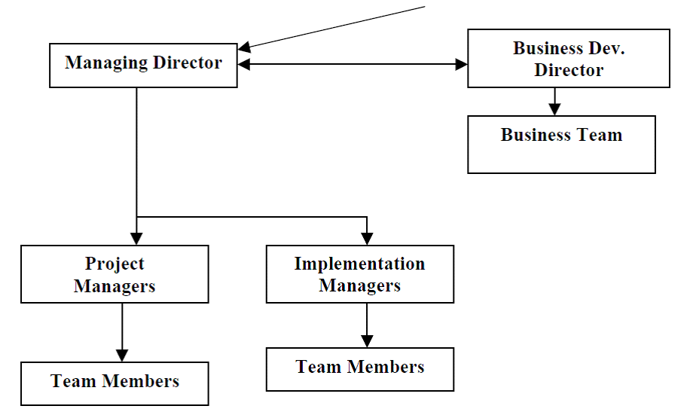

**Fig. 1.1 Organization Structure**

**1.6.1 Current Research and Development**

* The current R & D efforts are primarily aimed at the following segments in the healthcare industry:
* Developing a system for integrating medical schools with major hospitals for knowledge gathering, sharing and learning
* Developing a Clinical Decision Support System to aid doctors in difficult to diagnose cases using Artificial Intelligence and Probabilistic Techniques.

**1.6.2 New Technology Capability and Positions**

The organization has a process in place, which addresses the issue of incorporating emerging technologies into the product design. The process is as follows:

* Core committee on new development evaluates and identifies new technology for the purpose of integration.
* The research and development department identifies the resource and people and 1formulates the process for working while setting key performance indicator.
* A thorough study of the new technology along the tools is made and documented.
* Estimates are made as to the impact of the new technology on the products developed by the company.
* Effort estimates are made for introducing the new technologies
* Client feedback is received about the efforts needed and the advantages of the new technology.
* The core committee takes a knowledgeable decision as to the advantages and efforts required and approve the introduction of the technology
* The affected personnel are trained in the new technologies
* The new technology is introduced and the product is enhanced
* The clients are informed about the enhancement and introduction of related documents are prepared for the changeover
* The clients are guided in implementing the new technologies

Being a technology driven company we are always exploring ways of enhancing our product capabilities and aim at providing the latest state-of-the-art products to our customers. We have incorporated the PDAs and the smart card already in the system. We are currently evaluating blue tooth capability and the Tablet PC relevance to the field.

**CHAPTER 2**

**ABOUT THE DEPARTMENT**

**2.1 Research and Development Centre**

Pralotech Solutions have the ability to architect, develop and maintain any complex software applications. Pralotech Solutions development team and research team is committed to continuing research and development in the rapidly evolving fields of software development and IT, so that informed decisions can be undertaken at the appropriate time regarding future technology choices and adoption and to help drive the continuing evolution of our software architecture.

Over the course of several years, PRALOTECH SOLUTIONS has used the benefit of its knowledge and experience of developing enterprise wide, web based applications coupled with its continuing research and development activity to develop its own in-house web based software architecture and supporting framework on which all of its current and future web based solutions are based. Conforming to the latest industry standards and best practice, PraLoTech software architecture has proven to be a reliable, robust, and scalable foundation on which to build its software products. A qualified and highly specialized team with multi-disciplinary approach forms the technical core at PraLoTech. This repository of talented and committed software developers has a proven track record to ensure success in IT solution implementation. With skills ranging from business process re-engineering to application development, Pralotech Solutions technical team seeks to constantly enhance and expand its technical knowledge. Capturing knowledge through procedures and processes is the premise on which the entire organization works. Pralotech Solutions resource base consists of IIT engineers (three including the Directors), management graduates, masters in computer applications and domain experts from various fields.

Pralotech Solutions has a state of the art Software Development Centre located at Bangalore which also hosts a Data Centre with 100 MB bandwidth for the data transfer. The development centre and data centre runs in fully secure mode.

Pralotech Solutions is very prompt providing projects within deadline of project, which it improves the reliable and robustness.

**2.1.1 System Software and Programming Tools**

The software team at Pralotech Solutions has extensively worked on various flavours of Unix and Windows based environment. Few of the Unix operating systems, which have been used by the organization, are Sun Solaris, Tru64 UNIX & Linux.

The team at PRALOTECH SOLUTIONS has developed large scale and complex applications on Oracle, SQL Server and DB2. There is also substantial working expertise on MySql and MSAccess.

Pralotech Solutions stay relevant to their enterprise customers by helping them with transformational technology solutions utilizing SMAC structure and help in their growth journey and tailored offerings under various technology domains has been providing best quality, timely & cost effective solutions to its clients & has developed a long term strategic partnership with them all across the world.

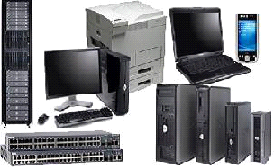

**Fig.2.1 System Software and programming tools**

The web server experience extends to the following:

* Apache on Unix and NT Servers
* IIS on NT Platforms
* JDBS
* SQLYOG
* Netbeans IDE with Servers

Operating Systems : Windows 7, Windows 8/8.1/10

Database Environment : DB2, Oracle, SQL Server, SQLYOG, MySQL.

Languages : Python, Java, EJB, XML, RMI, WAP, C/C++, CL/400, ASP and COBRA

Web Enabled Systems : MS-IIS, Visual Interdev, Web sphere, Web logic

Front End Tools : Tkinter, Visual Basic, Visual C++, Power Builder,

Web Designing Tool : FrontPage 2000, Mysql YOG

Data and Object Modeling : Rational Rose

Our Team members have extensive knowledge in Oracle Products ranging from Oracle 7.3 to 10i, Developer 6i, Oracle 10iAS and other oracle products.

Goal management is about more than just the annual assigning of goals and reviewing of employee performance. It's about getting every employee to use and develop their talents, skills and experience to help the organization meet its overarching goals. Goal setting is one of the most critical steps in effective performance management. Too often, managers and employees set goals that are not SMART or in line with corporate strategies, resulting in lost productivity and disengaged workers. Goal management is more than just a once-a-year exercise – it is an opportunity to align the focus of the entire company, clarify performance expectations, and guide employees to success.

Employee Perform makes it easy to align employee goals with business objectives and effectively guide employee performance and development year-round**.** Employees Perform flexible performance reviews helps link employee goals to the departmental goals, and to organizational goals - ensuring every employee is devoting his or her time and attention to critical and important activities.

|  |  |  |  |
| --- | --- | --- | --- |
| SET | ALIGN | MONITOR | ASSESS |
| Employee performance makes it easy for managers and employees to set SMART goals at the beginning of review cycle. | Easily cascade the company objectives to individuals or teams and link personal goals to organizational success | Log in year-round to update and comment on goals and track progress throughout the entire review cycle. | Measure goals using any rating scale that you choose. Comments & 360° feedback help ensure ratings are clear and accurate. |

**Traditional IT Organizational Structure Issues:**

Traditional IT organizations are typically structured to support vertical business units and applications. The roles, responsibilities, skills and budgets are focused on several discrete projects that address specifically business activities .In the traditional IT organization, projects are scoped and implemented without fully recognizing the core business processes that span business units.

Without an enterprise view, organizations lose the opportunity to implement the most effective solutions. In addition, typically the business requests enhancements to existing applications as a way to address immediate business needs quickly. This, along with a lack of shared vision between IT and business areas, results in enhancements to applications without fully considering the underlying business processes.

Marketing department advances the business and drives offers of the items and administrations. It gives the vital exploration to recognize and target clients and different audiences. The marketing department consists of Marketing and Sales departments. The presales department further contains Healthcare, Education, Retail and Networking departments. Thus opportunities to radically improve business processes are overlooked.

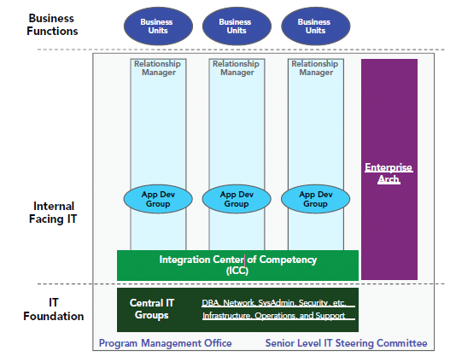

**Fig. 2.2 IT Organization Layers**

**2.2 Department Centered Organizations**

Department centered development organizations start to become practical as a group grows above 25 developers or 5 projects. At these staffing levels, there are sufficient people to form multiple departments centered on particular software skills or life cycle areas. For instance, a 40-person group might have departments for:

• System and database administrators

• User interface programmers

• Application programmers

• Configuration management, test, and quality assurance

A common mistake in department-centered organizations is to break software architects into a separate department or group. We have found this can lead to elitism and be very counterproductive. First, it starts to separate the architects from the developers who are doing the actual implementation. Architects thus become more quickly out-of-touch with the latest development methodologies actually being used. Also, while every developer does not want to be an architect, every developer likes to have some say in the design. If developers are too separated from architects, they may have a built-in incentive to prove the architect’s design was wrong by not working there hardest to implement it. When this happens the architect will most likely blame the problem on developer incompetence than on any architectural flaws. The whole iterative development process becomes harder to implement smoothly.